SYSTEM DESIGN

1. ARCHITECTURE DIAGRAM

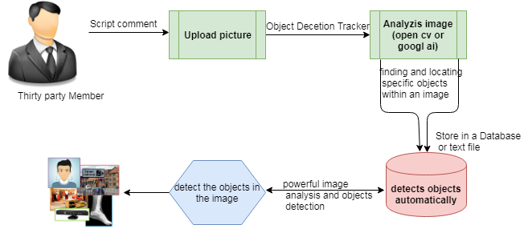

1. COMPONENT DIAGRAM
   1. User

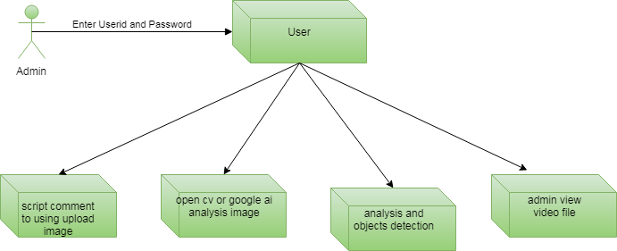

1. ER DIAGRAM
   1. User

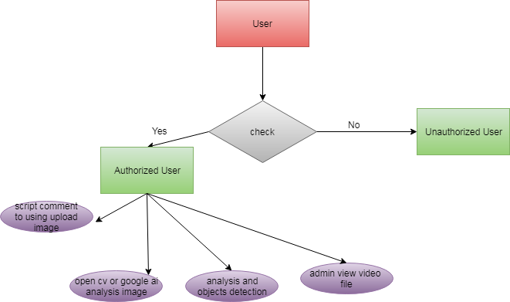

1. USE CASE DIAGRAM
   1. User

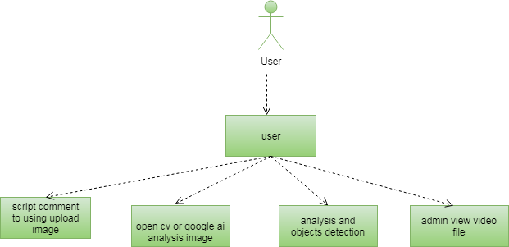

1. CLASS DIAGRAM

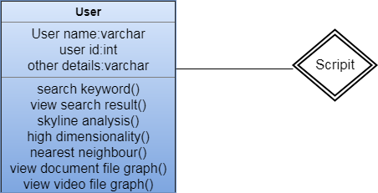

1. DATA FLOW DIAGRAM
   1. User

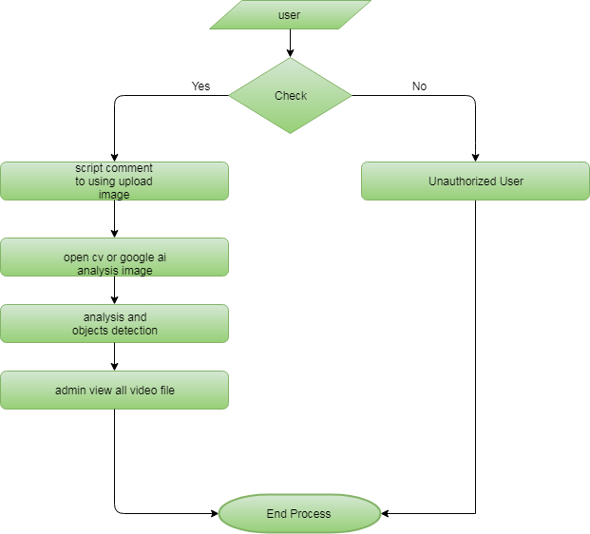

1. ACTIVITY DIAGRAM
   1. User

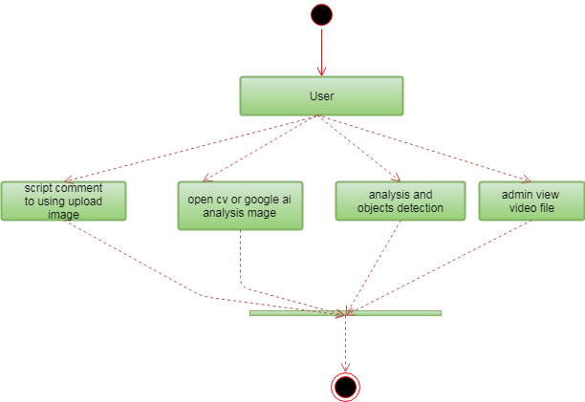

1. SEQUENCE DIAGRAM
   1. User

